Behaviour Study of Bike Driver and Alert System Using IoT and Cloud

**Punit Gupta**

Department of Computer Science Engineering,

Jaypee University of Information Technology

Himachal Pradesh, India

punitg07@gmail.com

Aditya Mohan

Department of Electronics and Communication Engineering,

Jaypee University of Information Technology

Himachal Pradesh, India

**adityamohanjuit@gmail.com**

**ABSTRACT**

In this paper we present a smart and safe Bike riding system to provide a safe and an intelligent driving features with accidental, speeding and rash driving alerts using fog computing. The system is based on the Ethernet based 2nd Generation Intel Galileo Board. This intelligent system will be embedded in the upcoming bikes and motorcycles to prevent speeding, determine driver behaviour and rash driving accidents. The whole idea of the system is to generate an alert to the user and provide caution alert to the user about their driving statistics and warn them as necessary. The system is embedded with various sensors like accelerometers, gyroscope and GPS to make this system an intelligent one. The proposed outcome of the system aims as multiple benefits of preventing accidents, maintaining the ride statistics and getting the directions for the ride. Smart Bike is an IOT based ride system. In today’s world, everything is getting automated.

**Keywords**

Internet of thing (IoT), Power consumption smart devices, Home automation, Fog computing, Cloud computing.

# INTRODUCTION

The future of Internet of Things and fog computing increases the horizons of our vision and also enabling public to access and contribute rich resources about probably everything ever existed in the world. The success of the convergence of the internet of things and the world giving the capability to share experience and personalized insights with the humans also shows great potential for integration with place which need manual labor which can be at some points time taking and inaccurate. Information distribution may be rewarded through inducements, thus transforming the Internet of Things from mere manufacturing commercial applications to an intelligent infrastructure that would reduce human labor and could accomplish task in comparably less time and most accurately also allowing us the trading of enriched information and accelerate business innovation. Being open source and end-user programming will enable people to share to the Internet of Things with data, valued resources and functionalities.

The Internet of Things is in itself the summation of various technologies based on wireless means, system setup which store data retrieved from various hardware nodes(sensors) internet which connects the above mentioned systems and services for useful inference and inference based decision making for bringing the generated data to use. This integration has led to quick deduction and compilation of results along with more rapid creation of efficient frameworks for boosting applications in the industry which include automation, higher risk tolerance and quicker delivery of services.

This interconnected device layout coupled with efficient and robust methods of data transfer has not only resulted in accelerated computation of traditionally high resource and time consuming tasks like service-threshold evaluation and alert generation but also have greatly reduced the risk factors associated with the increase in the user database of these services, mainly addressing the issues of high-end investment required for installation and commencement of these services, also mitigating the chances of low user satisfaction owing to more accessible and cheaper device interconnection setup and low maintenance costs involved for the subscription and troubleshooting of any of the associated services. The internet of things have found out its application in almost all the industries ranging from healthcare to risk management and its biggest advantage is the rate of automation provided by it, which has helped generate real-time data conclusions using commercial grade material, saving countless hours of effort and also many human lives. Based on one such application, in this paper we propose an IoT based smart bike ride system that focuses on preventing the increasing road accidents caused due to speedy and rash driving. This Intelligent system will maintain the statistics as well as generate alerts when necessary about the riding style and hence warn the user.

Paper is structured as follows: Section 2 presents existing work from the field of IoT and smart devices for vehicles like car , bike and trains etc. Section 3 discourses the problem statement and proposed model to detect rash driving and alert system. Section 4 describes the simulation setup, scenarios and results as compared to normal and safe driving. Section 5 concludes the work with result outcomes and future work.

# RELATED WORK

A lot of research and development is going in the field of Internet of Things which includes from connecting to devices, collecting data from them, analyzing those large bytes of data and performing the required operation on the data and generates the desired output. Many IOT devices in all the fields including medical and healthcare, Home automation, Agriculture etc. have being developed and the same goes for our Smart Petrol Pump solution system. Some of the related IOT devices are discussed below.

**1. eCall**

eCall [2] is a service in Europe which serves as an example of an authority undertaking which aims to increase telematics of vehicles. By the time of mentioning, the grand European coalition had set it's target to install the eCall model by 2015[10]. This entire system is fixed inside a vehicle and is attached to the air-bag system to sense a collision in real-time It's provided with a user-operated button to ask for assistance for a co-passenger with body issues or to notify the concerned authorities of some other vehicle. It has been equipped with a Global Positioning Service incoming-acceptor for finding out the vehicle and it's anticipated route before the mishappening took place.//eCall is triggered by itself when the embedded sensors or trigger-attachments find out of a damaging collision.



Figure 1. Ecall System

After this service is executed for the first time, the contact sequence of the European Union(which is 112), sets-up a cellphone link to the apt quick response unit quarters( or public safety assuring centres), sending the detail of the happening(or Minimum Set of Data -> M.S.D.) to the saviour teams(also incorporating the time of occurence) , the to-the-point location of the affected vehicle and the direction in which the vehicle headed. A eCall can be initiated by thy-self on pressing a button given on the vehicle, for e.x. by an individual who had a look at the scene.//https://ec.europa.eu/transport/themes/its/road/action_plan/ecall_en

2. Contran 245 [9]

In Brazil, a legislation was presented which demanded all fresh vehicles manufactured or brought to Brazil to be installed with GPRS-enabled locating systems for bringing down car thefts. This idea is on its way to fruition.

This bill or act has the ability to transform Brazil into one of the biggest telematic market in the universe, including car tracing and other services, containing simple tracing as needed by the act to features including fleet caretaking and setup and emotion response monitoring for insurance issues.

3. MIROAD

Here Johnson et al[1] mentioned of a which places vehicle driving styles into average, hostile and ultra-hostile. Like the above cases, sensors like accelerometers, gyroscopes, cameras and magnetometers) on an iphone were used with the data generated into a singular classification program based on the DTW(Dynamic Time Warping)algorithm. That system “spoke” i.e. gave an audible output for alert generation i.e. if the threshold values were exceeded.

In the U.S., a significant amount of insurance companies have begun implementing service consumption-based insurance to educe the costs for these customers and also to advocate secure driving.

In Italy gains of service consumption-based insurance has resulted into a new law.Private companies like Octo Telematics provide recommendations for insurance and other tasks relating to the automotive industry by accumulating vehicle location and accident data along with driver behavior info. To support its pay-as-you-drive policies.

Some developments have taken place in utilization of mobile devices(cell-phones) for calculation of various parameters and alert provision. As an example, an app. On the Android platform made by Chirgupta et al [7] which provides quality charts of that specific driver. They had incorporated an accelerometer, a global positioning service sensor and the in-built camera device for capturing the feed. Ranges for accelerating securely were mentioned in the code and values breaking beyond their extremes (thresholds) marked the happening of the associated event.

**3. PROPOSED MODEL**

In the proposed model we introduce a smart and safe riding intelligent system that provides the driver, along with the concerned authorities(parents etc.) with safe and intelligent driving features including that of accident alerts, rash driving and speeding alerts. The system is based upon on an Inter Galileo Gen 2 (Quark Processor) based system which acts as the transmission-brain of the whole system and Amazon web service as cloud controller. The system is connected to the network via Internet and a database is maintained consisting of the whole ride details, the speed statistics and alerts if any. This system helps the one concerned person in relationship to bike driver and the concerned authority to study and stop rash drivers.The system consists of an Inter Galileo Gen 2 (Quark Processor). The sensors used are GPS module, gyroscope and Accelerometer which details us upon the velocity as well as the tilt of the motorcycle. With the help of the gyroscope we are able to determine the tilt angle and the rotation of the motorbike and with the help of accelerometer, the velocity of the motorbike is calculated.

Our system responds to the speed alert when a motorbike crosses a threshold speed which can be determined by the accelerometer. It can also detect whether the person is doing rash driving with the help of sudden rotational change readings in the gyroscope. The gyroscope can determine the rotational reading of the bike and its tilt angle and thus can help to detect the rash driving occurrence. The proposed system focuses on the guidelines set by the local official authorities which include maximum speed, minimum speed and sudden acceleration which are altogether combined with the measured tilt angle to generate a tested and calibrated parameter which single-handedly generates an alert for rash driving which is sent to the user and stored in the database. The authorities which can utilize the alert and stored data include parents, government officials in-case of any lawsuit filing, the data can act as an conduit for showing the statistics of the moment of event occurrence, thereby helping legal undertakings proceed at an accelerated rate. Also, the intelligent system is also able to determine the accidents through sudden change in a orientation of the motorbike and will let you know the if you are over speeding in an area where speed limit is restricted.

Proposed model shown in figure 2.2 allows a user to upload the ride data to cloud web server using cloud software as a service (SaaS) and Amazon as service provider. Data uploaded to the web server is bike velocity, change in acceleration with bike tilt and GPS co-ordinates to the web server. The web server is responsible to compute the data according to the threshold value and generate alert according. Alert generation includes the first phase of work. Alerts are send to the authorized person in case of any rules violation listed below.

Second phase includes comparing the data with the data feed of a normal driver and analyze the behavior of the driver by comparing the both. Analyzing includes find the percentage of drastic difference in normal and rash driver velocity data, acceleration dataand tilt degree data, if the either of % change is to high the alert will be generated. The data will be useful the authority to rate the driving skills of the bike driver and if found to not suitable a strict measure could be taken. Similarly, will help the driver family to take a look over the students and other members of family.

Cloud service helps to log and analyze large set of logged data parallel and cloud can scale the service if large number of devices is connected to it. Cloud service is also responsible to send the data with analyzed data to the authorities for effective actions.

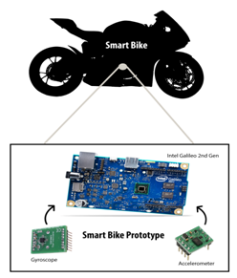

**Figure.2.1. Physical layout cum component set-up of the proposed model**.

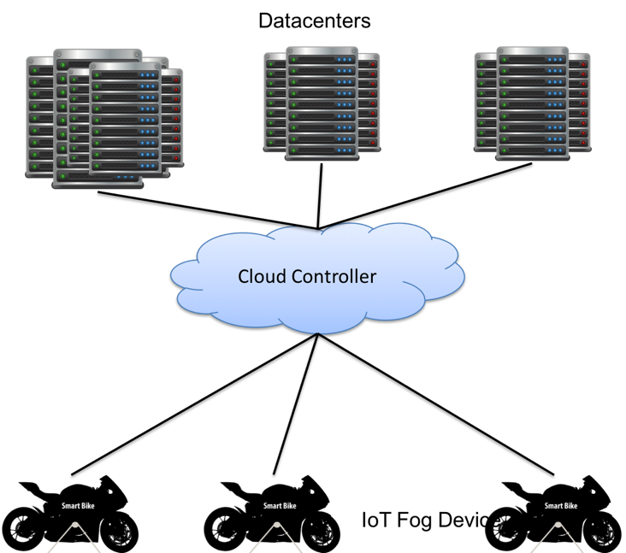

**Figure.2.2.Proposed architecture**.

**Figure.2.3.Proposed behavior study model**.

**Figure.2.3.Proposed model for alert**.

The entire process can be executed in parallel- in the first case, it can be used for direct data retrieval and alert generation. In the second case, location tracking can be enabled using the GPS available on the user's end. In this case guidelines issued by the local governing authorities shall influence the threshold values for alert generation.

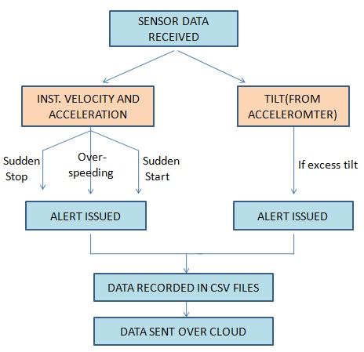

**Figure. 3.1Pictorial representation of the working of the system.**

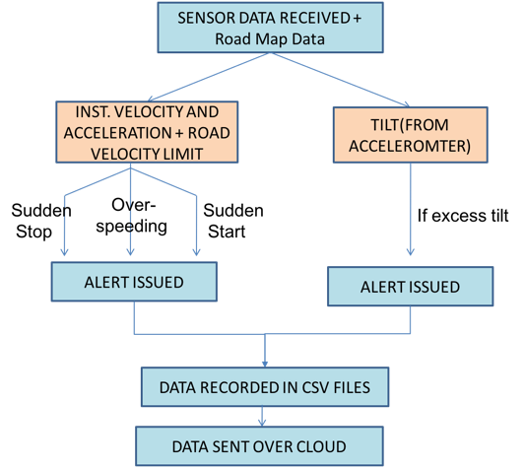

**Figure. 3.2 Pictorial representation of the working of the system.**

The software part consists of a database server which helps to maintain the statistics of the ride details. The user can also set the GPS details for the ride using his smartphone by connecting it via the Bluetooth. The system uses the internet server to send the details of the location of the bike in case of accidents or rash driving. Real-time drive-statistics(with various alert parameters recorded) are sent via the Internet for complete data logging and future reference.

The hardware part consists of a GY-61 3-Axis accelerometer and the gyroscope sensor. The sensor used here is MPU6050.The MPU-6050 devices combine a 3-axis gyroscope and a 3-axis accelerometer on the same silicon die, together with an on board Digital Motion. Figure 3 and 4 shows the working of the individual sensors and how they are used for measuring the above-mentioned parameters.

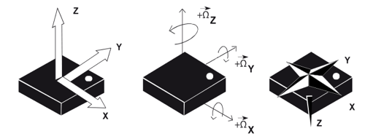

**Figure 3. Dynamics of the gyroscope for angle measurement.**

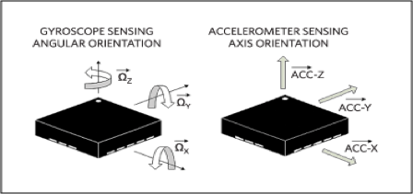

**Figure 4. Axial positioning of the sensors.**

**3.1 PROPOSED RULE SET**

We have framed out and deduced 4 conditions for categorizing any form of driving as rash driving, which include crossing a defined speed limit, sudden stop of a speeding vehicle, sudden acceleration of a stationary or almost stationary vehicle, and excess tilt of the bike on that specific instantaneous velocity at that moment of time which may result in skidding and Sudden stop may surprise the neighbor vehicles resulting in crash.

Set of rules and conditions are as follows:

* **CROSSING THE SPEED LIMIT**

Here we have defined a specific speed limit of 70km/hr above which if the vehicle goes, then an alert of “speed limit crossed” is generated and stored in the database. The data generated is for a specific time instant and if continued over a long period of time(more than 5-10 continuous iterations), would indicate intentional or self-imposed rash driving.

* **SUDDEN STOP**

If a moving vehicle suddenly stops(i.e. acceleration reduces significantly when its final velocity is highly reduced), then it indicates that either the vehicle was suddenly stopped via application of heavy brakes or either it as bumped into another solid, heavier object, either ways, both being the result of rash driving.

* **SUDDEN ACCELERATION**

If a person accelerates the bike all of a sudden then it indicates that either the vehicle was being mis-handled(i.e. being driven under some influence etc.) or it was bumped from behind by another object- both indicating towards rash driving by any of the associated parties.

* **EXCESS TILT OF THE BIKE**

If at any specific speed, if the vehicle tilts(about its centre of mass) excessively for a prolonged time period then it indicates that the person is sure to get his vehicle flipped, his knees raptured, or bump into any other object or vehicle having a probability of causing heavy damage to life and property.

* **AUTHORITY RULES FROM MAP**

The road layout taken for simulating the vehicle driving was of Downtown Manhattan(Lower Manhattan, New York, NY, USA), as shown on Figure 6. The simulation was performed in broad daylight conditions with the presence of mild traffic. The starting point of the road trip was from the 259 Adams Street near Brooklyn Bridge (40°41'45.6"N 73°59'19.3"W) to 6th Ave, Brooklyn, NY, USA(40°38'14.5"N 74°00'53.7"W) with an estimated ride time of 11 minutes. Total length of the road covered for making the observations was 6.8 miles. The road comprised of an estimated amount of 14 turns(including both sharp and mild turns).

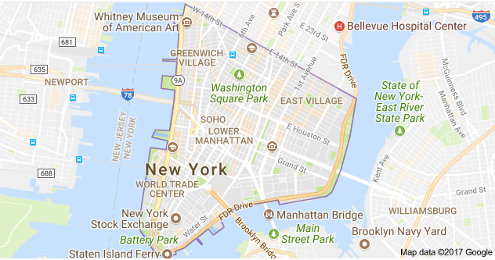

**Figure 6. Map Downtown Manhattan(Lower Manhattan, New York, NY, USA).**

* **SPECIFICATIONS OF HARDWARE USED**

Microcontroller: Inter Galileo Gen 2 (Quark Processor).

Sensors: GY-61 3-Axis accelerometer, Grove Rotary Angle Sensor v1.2

**4 Experimental Results**

The proposed IoT based Smart Bike System has been simulated with sensors been attached on bike with GPS connectivity. The testing is been done over road map over Downtown Manhattan(Lower Manhattan, New York, NY, USA) with all the rules of maximum speed at specific point of road from google maps as shown in figure 6.

Figure 7 shows comparison of acceleration change in driving of normal driver and rash driving as shown with blue and red color in graph. Figure shows a drastic fluctuation in speed as compared to smooth change in velocity in normal driver.

Figure 8 shows alert generated due to sudden change in acceleration as shown in green and red shows the acceleration change due to rash driving as compared to a dataset of normal driver.

Figure 9 shows alert generated due to sudden change in velocity resulting in over speeding and an alert is generated due to over speeding as compared to the authority speed provided by google maps. If the speed greater than threshold

Figure 10 shows alert generated due to sudden stop resulting in high probability of bike disbalancing and an alert is generated due to this as compared normal driver shown in blue color .

Figure 11 shows alert generated due to excess tilt in bike resulting in high probability of bike disbalancing and an alert is generated due to this as compared normal driver shown in blue color and high peaks shows excel tilt than threshold value shown in green color in figure 10.

Table 1

|  |  |  |
| --- | --- | --- |
| **Violation type** | **Total** | **Count of violation** |
| TILT | 599 | 34 |
| SUDDEN STOP | 599 | 4 |
| OVER SPEEDING | 599 | 115 |
| SUDDEN ACCELERATION | 599 | 6 |
| HIGH ACCELERATION | 599 | 125 |

Table 2 Analysis output

|  |  |
| --- | --- |
| **Violation type** | **% Violation** |
| TILT | 5.68% |
| SUDDEN STOP | 0.67% |
| OVER SPEEDING | 19.20% |
| SUDDEN ACCELERATION | 1.00% |
| HIGH ACCELERATION | 20.87% |

Output of analysis phase from figure 7-11 shows that 19 percentage high in velocity, 20 % high in acceleration and 5.6 % high in tilt ration as compared to normal driver, which is sufficient to take action against the driver and send an alert.

**5 Conclusion**

From experimental result section, it is clear that proposed intelligent system is the best in its kind for providing better alerts and can detect more type of rash driving as compared to normal driving skills

The main idea of this system is to minimize the road accidents which are increasing day by day by alerting and warning the driver of their ride styles and providing them the best security necessary and also send the alerts to the parents and one concerned person about the driving behavior of the driver. State authority can use this data for grapping and finding the driver with these unfit driving skills and can be used to study the driving behavior or a specific area.

**Figure. 7 Sudden of acceleration change**

**Figure. 8 Sudden Acceleration Alert**

**Figure. 9 Alert generated due to sudden change in velocity**

**Figure. 10 Sudden stop Alert**

**Figure. 11 Sudden excess tilt in bike**

**References**

1. Johnson DA, Trivedi MM. Driving style recognition using a smartphone as a sensor platform. InIntelligent Transportation Systems (ITSC), 2011 14th International IEEE Conference on 2011 Oct 5 (pp. 1609-1615). IEEE.
2. Pinart C, Calvo JC, Nicholson L, Villaverde JA. ECall-compliant early crash notification service for portable and nomadic devices. InVehicular Technology Conference, 2009. VTC Spring 2009. IEEE 69th 2009 Apr 26 (pp. 1-5). IEEE.
3. Lea R, Blackstock M. City hub: A cloud-based iot platform for smart cities. InCloud Computing Technology and Science (CloudCom), 2014 IEEE 6th International Conference on 2014 Dec 15 (pp. 799-804). IEEE.
4. Schietekat JM, Booysen MJ. Detection of reckless driving in the Sub-Saharan informal public transportation system using acceleration-sensing telematics. InEUROCON, 2013 IEEE 2013 Jul 1 (pp. 597-601). IEEE.
5. Shubhada Vital Poojary, Rashmi, Sudheer Shetty,“Humps and Pothole Detection and Alerting System for Safe Journey”,International Research Journal of Engineering and Technology (IRJET) Volume: 03 Issue: 05 | May-2016
6. Chu HL, Raman V, Shen J, Choudhury R, Kansal A, Bahl V. In-vehicle driver detection using mobile phone sensors. InACM MobiSys 2011 Apr 20.
7. Kalra N, Chugh G, Bansal D. Analyzing driving and road events via smartphone. International Journal of Computer Applications. 2014 Jul;98(12):5-9.
8. Chen K, Lu M, Fan X, Wei M, Wu J. Road condition monitoring using on-board three-axis accelerometer and GPS sensor. InCommunications and Networking in China (CHINACOM), 2011 6th International ICST Conference on 2011 Aug 17 (pp. 1032-1037). IEEE.
9. Zhang Y, Lin WC, Chin YK. A pattern-recognition approach for driving skill characterization. IEEE Transactions on Intelligent Transportation Systems. 2010 Dec;11(4):905-16.
10. Jalali S. M2M solutions—Design challenges and considerations. InIntelligent Computational Systems (RAICS), 2013 IEEE Recent Advances in 2013 Dec 19 (pp. 210-214). IEEE.